ISLAMIC UNIVERSITY OF TECHNOLOGY
DHAKA, BANGLADESH
ORGANIZATION OF ISLAMIC COOPERATION
SWE 4202: Object-Oriented Concepts I Lab Assignment
Title: Basic of C#
Name: Antara Arifa Mullick
Student ID: 210042132
Department: Computer Science and Engineering
Program: B.Sc. in Software Engineering
Date: 04/01/2023

What is C#
The C# programming language was developed by Microsoft as a part of the.NET framework. It is said "C-sharp." It is a modern, object-oriented language that aims to be uncomplicated, efficient, and easy to learn. The use of variables in C# requires that they be declared with a specific data type because the language is statically typed. The variety of data types that C# provides includes integers, floating-point numbers, characters, and strings, to name just a few. C# also supports concepts from object-oriented programming including inheritance, polymorphism, and encapsulation, allowing programmers to create and reuse code. Applications for Windows, the web, and mobile devices are frequently created in C#. It works with many different frameworks and development tools, including as the.NET framework, Visual Studio, and Xamarin.
The first five lines of the code that begin with "using" are referred to as library functions. To print Hello World, we used the "Console.WriteLine" command.
Let’s see the code :
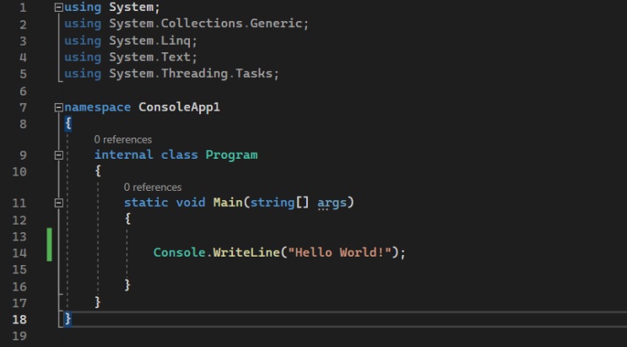

The output will look like as below :

Variables
A variable in is a place in the memory of a program where a value can be saved and retrieved. The size and organization of a variable's memory, the range of values that can be stored inside, and the set of operations that can be carried out on the variable are all governed by the type of the variable. To declare a variable in C#, we need to specify its data type.
For example:
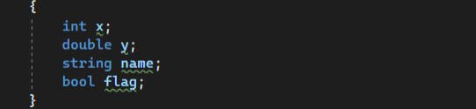
Here, ‘x’ is an integer variable, ‘y’ is a double-precision floating-point variable, ‘name’ is a string variable, and ‘flag’ is a Boolean variable. Once a variable is declared, we can assign a value to is using the assignment operator (‘=’).
For example:
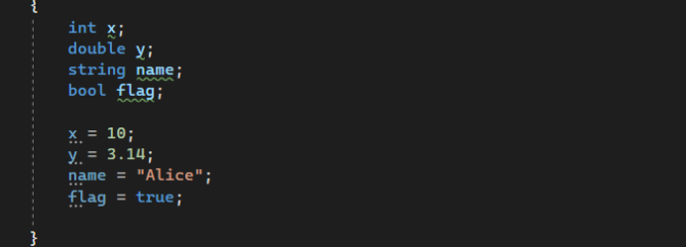

We can also declare and assign a value to a variable in a single statement, like this:
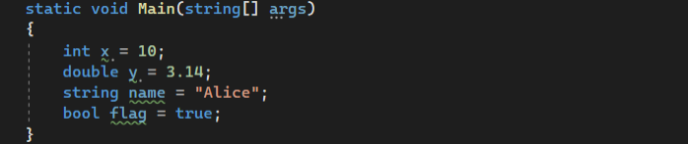
C# is a strongly typed language, which means that variables must be declared with a specific type, and the type of a variable cannot be changed once it is declared. However, C# does support type coercion, which allows us to convert a value of one type to another type, as long as the conversion is possible.

For example:
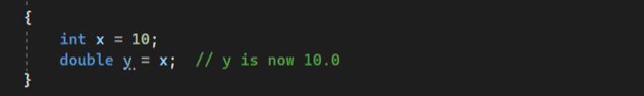

Data type
A data type is a classification of types of data that determines the possible values for that type, the operations that can be performed on it, and the way it is stored in memory. C# is a strongly typed language, which means that every variable and expression has a specific data type. There are several built-in data types in C#, including: • Value types: These are simple types that hold a single value in memory. Value types include integers (int), floating-point numbers (float, double), Booleans (bool), and characters (char). • Reference types: These are types that hold a reference to an object in memory. Reference types include strings (string), arrays (int[], string[], etc.), and class instances. • Enumerations: These are value types that represent a set of named constants. Enumerations are declared using the ‘enum’ keyword. • Nullable types: These are value types that can hold a special value called null, which indicates that the variable has no value. Nullable types are declared using the? operator, like this: ‘int? x = null;’. When declaring a variable, we must specify its data type.
For example:
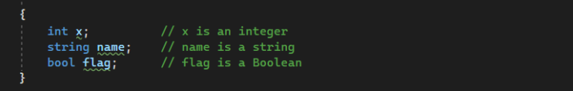
It's important to choose the appropriate data type for our variables based on the values they will hold and the operations we need to perform on them. Using the wrong data type can lead to errors or unexpected results in our program.

Number
There are several built-in data types for storing numeric values in C#: • Integers: These are whole numbers that can be positive, negative, or zero. C# has several integer types, including byte, short, int, and long, which can store values of different sizes. The byte type is an 8-bit unsigned integer, the short type is a 16-bit signed integer, the int type is a 32-bit signed integer, and the long type is a 64-bit signed integer. • Floating-point numbers: These are numbers with a decimal point. C# has two floatingpoint types: float and double. The float type is a single-precision floating-point number (32 bits), and the double type is a double-precision floating-point number (64 bits). • Decimal numbers: These are numbers with a decimal point that have a higher precision than floating-point numbers. C# has a decimal type for storing decimal values. The decimal type is a 128-bit data type that is suitable for financial and monetary calculations, where precision is important. Here are some examples of declaring and assigning values to numeric variables in C#:

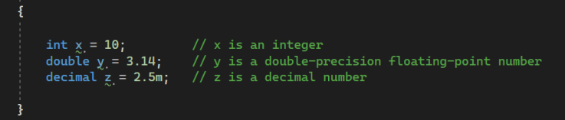

Boolean
A Boolean data type is a type that can hold only two values: true or false. The Boolean type is used to represent a binary choice or a logical condition. To declare a Boolean variable, we can use the ‘bool’ keyword, like this:
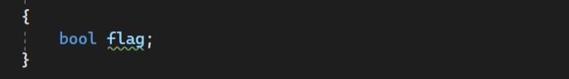
We can also declare and assign a value to a Boolean variable in a single statement, like this:
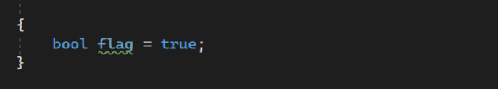
Boolean variables are often used in conditional statements, like ‘if’ and ‘switch’, to control the flow of a program based on a ‘true’ or ‘false’ condition.

Branches
A branch is a statement that allows a program to execute different blocks of code based on a particular condition. There are several types of branches available in C#, including:
1. if: This statement allows a program to execute a block of code if a specific condition is true.
For example:
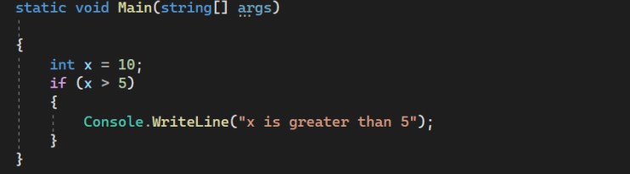
2. if-else: This statement allows a program to execute a block of code if a specific condition is true, and a different block of code if the condition is false.
For example:
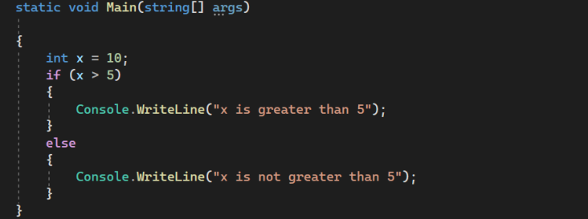
3. switch: This statement allows a program to execute a block of code based on the value of a specific expression.

For example:
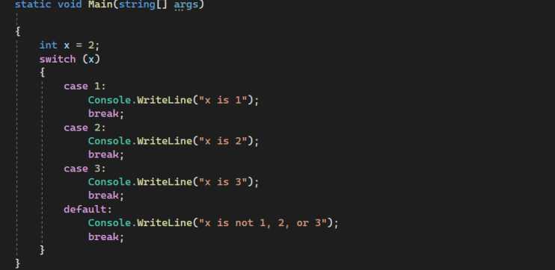

4. goto : This statement allows a program to jump to a labeled statement in the same function. For example :
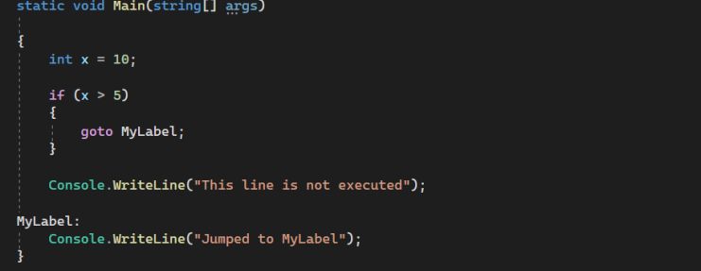
It's important to use branches appropriately in our code to create clear and maintainable programs.

Arrays
An array is a collection of items of the same data type, stored in contiguous memory locations. Arrays are used to store multiple values in a single variable, and they are commonly used in programming. Here is an example of how to declare and initialize an array in C#:
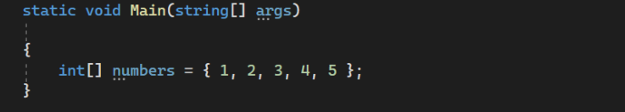
In this example, ‘numbers’ is an array of integers that contains 5 elements: 1, 2, 3, 4, and 5. We can access individual elements of an array using an index, which is the position of the element in the array. The first element has an index of 0, the second element has an index of 1, and so on. Here is an example of how to access elements of an array:
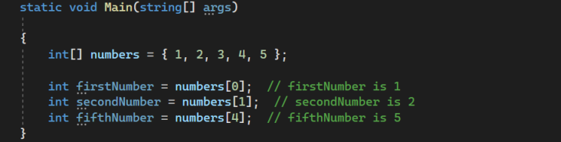
We can also use loops to iterate through the elements of an array. For example:
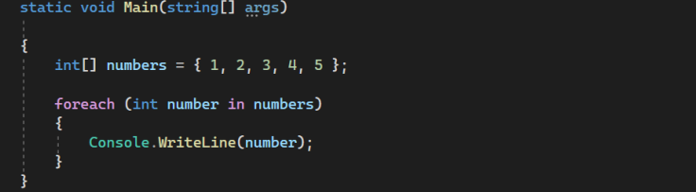
This will print the elements of the numbers array to the console: 1, 2, 3, 4, 5.

There are many other operations that can be performed on arrays, such as sorting, searching, and resizing. Arrays are a useful and important data structure in C#, and they are widely used in programming.

Basic Data Structures
There are several basic data structures that are commonly used to store and manipulate data in C#. These include:
• Arrays: An array is a collection of variables of the same data type, stored in contiguous memory locations. Arrays are indexed, so we can access and modify individual elements using an index. For example:
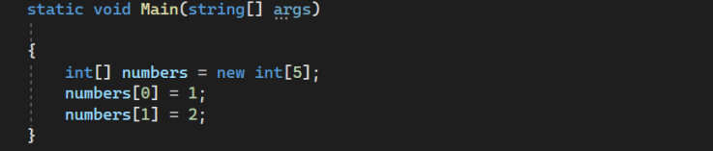
• Lists: A list is a collection of objects that can be of any data type, stored in a dynamically allocated memory. Lists are similar to arrays, but they can grow and shrink as needed. Lists are implemented using the List class in C#, where T is the type of objects the list will contain. For example:
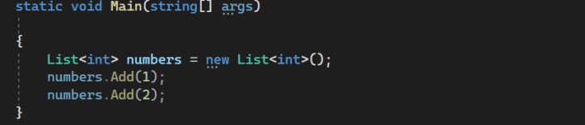
• Dictionaries: A dictionary is a collection of key-value pairs, where each key is unique and is used to retrieve the corresponding value. Dictionaries are implemented using the Dictionary class in C#, where TKey is the type of the keys and TValue is the type of the values.
For example:
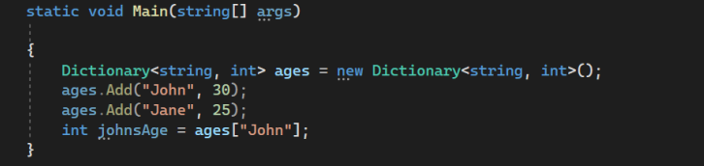
• Sets: A set is a collection of unique elements, where each element can only appear once. Sets are implemented using the HashSet class in C#, where T is the type of elements in the set. For example:
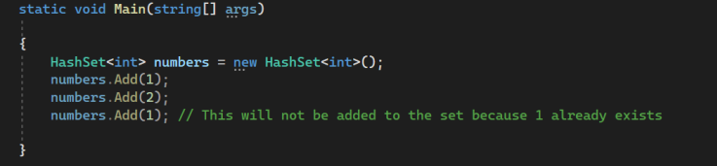
There are many other data structures available in C#, such as stacks, queues, and trees. These data structures are typically implemented using classes in the .NET Framework, and they provide specific features and capabilities for storing and manipulating data.

Strings
In C#, a string is a sequence of characters stored in contiguous memory locations. Strings are used to represent text in C#, and they are immutable, which means that they cannot be changed once they are created. Here is an example of how to declare and initialize a string in C#:
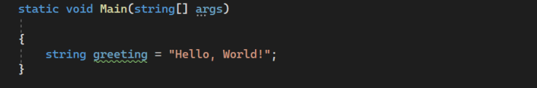
We can access individual characters of a string using an index, which is the position of the character in the string. The first character has an index of 0, the second character has an index of 1, and so on. Here is an example of how to access characters of a string:
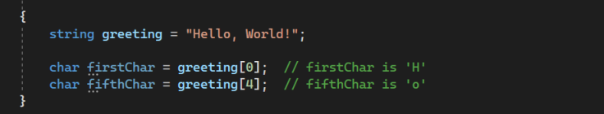
We can also use loops to iterate through the characters of a string.
For example:
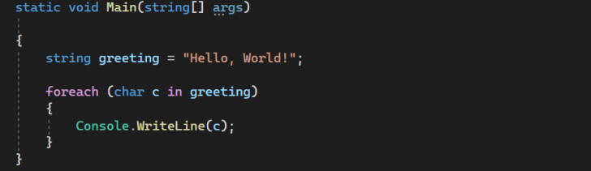
This will print the characters of the greeting string to the console: H, e, l, l, o, , , W, o, r, l, d, !.


There are many other operations that can be performed on strings, such as concatenation, searching, and formatting. Strings are a fundamental data type in C#, and they are widely used in programming.

Methods
In C#, a method is a block of code that performs a specific task and can be called from other parts of a program. Methods are a way to organize and reuse code, and they allow we to define a set of instructions that can be executed multiple times with different input values. Here is an example of a simple method in C#:
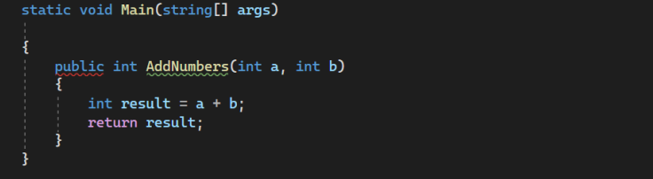
This method, called AddNumbers, takes two integer arguments a and b, adds them together, and returns the result. The public keyword specifies that the method is accessible from other parts of the program. The int keyword before the method name specifies the data type of the value that the method returns.
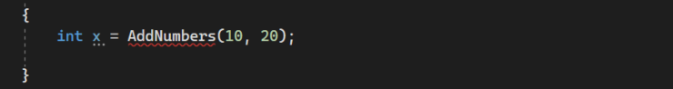
To call this method from another part of the program, we can use the method name followed by the required arguments in parentheses:
This will call the AddNumbers method with the arguments 10 and 20, and assign the result (30) to the variable x. Methods can also have optional parameters, which allow we to specify default values for some or all of the arguments. Optional parameters are defined using the = operator followed by a default value.
For example:
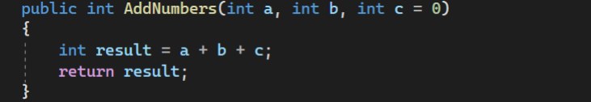
In this case, the third argument c is optional, and if it is not specified when the method is called, it will default to 0. We can call this method with either two or three arguments
Methods can also have different access modifiers, such as public, private, and protected, which determine the visibility and accessibility of the method within the class and to other classes. Finally, methods can also have different parameter passing mechanisms, such as value parameters, reference parameters, and output parameters, which control how the arguments are passed to the method and how the changes made to the arguments inside the method are reflected in the calling code.

How to take input
To take input from the user in a C# console application, you can use the Console.ReadLine() method, which reads a line of text from the console and returns it as a string. For example, the following code reads a string from the console and stores it in a variable:
To read a numeric value, you can parse the string input using the appropriate data type conversion method. For example, the following code reads an integer from the console and stores it in a variable:
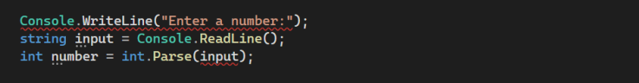
Note that the Parse method can throw an exception if the input string is not a valid integer. To handle this, you can use a try-catch block to catch the exception and handle it appropriately.

For example:
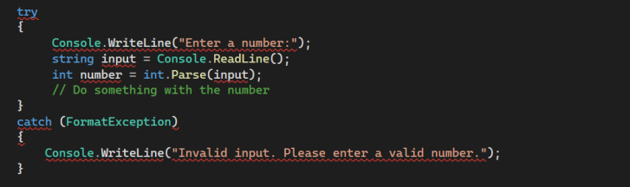
You can also use other data type conversion methods, such as ‘double.Parse’ and ‘float.Parse’, to read floating-point values, and ‘bool.Parse’ to read a boolean value. Here is the complete code for a simple console application that reads a name and an age from the user and prints a greeting:

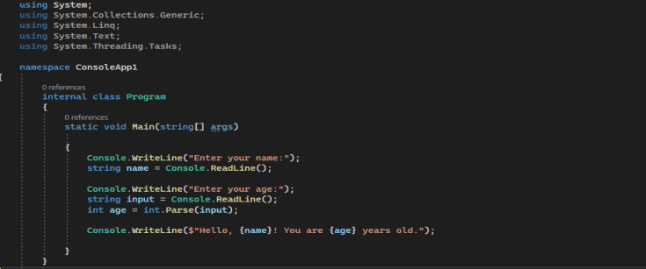

Type conversion
Type conversion refers to the process of converting a value of one data type to another data type. There are two types of type conversion in C#: implicit conversion and explicit conversion. Implicit conversion, also known as automatic type conversion, occurs when the type of the value being assigned is compatible with the type of the variable, and no data loss will occur as a result of the assignment. Implicit conversion is performed automatically by the C# compiler, and it does not require any special syntax. For example, the following code performs an implicit conversion of an int value to a long value:
In this case, the value of x (10) can be stored in a long variable without any loss of precision, so the compiler will automatically convert the int value to a long value. Explicit conversion, also known as type casting, occurs when the type of the value being assigned is not compatible with the type of the variable, and a data loss may occur as a result of the assignment. Explicit conversion requires the use of a typecast operator, which is a set of parentheses containing the name of the target data type. For example, the following code performs an explicit conversion of a double value to an int value:
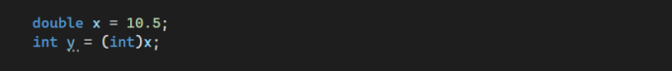
In this case, the value of x (10.5) cannot be stored directly in an int variable, because it has a fractional part that will be lost during the conversion. To perform the conversion, the compiler will use the typecast operator (int) to explicitly convert the double value to an int value. The result of this conversion will be 10. It is important to note that explicit conversion can result in data loss, and it may also throw an exception if the value being converted is not within the range of the target data type. Here is the complete code for a simple console application that demonstrates implicit and explicit type conversion:
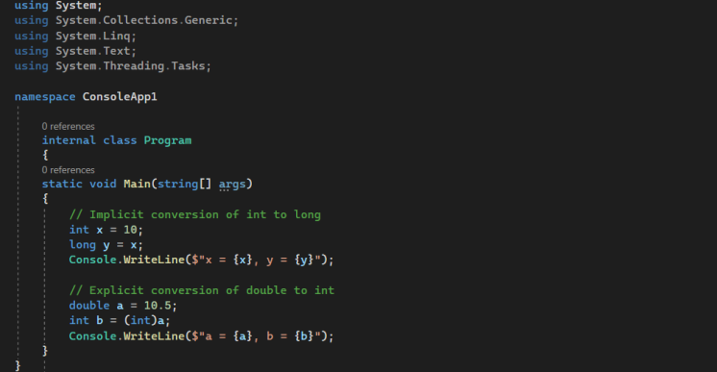
The output will be like this:
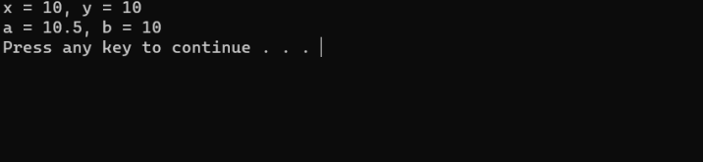

THE END

